YEAR 11 GENERAL HUMAN BIOLOGY
Task 2:
Characteristics of Life and Body Organisation Test
SCORES:

Multiple Choice: /15

Short Answer: /30

TOTAL: /45

_______ %
NAME:_____________________________

TEACHER:__________________________

DATE:______________________________

Section A: Multiple choice (15 Marks)
Answer all questions by circling the most correct answer on the multiple choice answer sheet.

1. a b c d 11. a b c d
2. a b c d 12. a b c d
3. a b c d 13. a b c d
4. a b c d 14. a b c d
5. a b c d 15. a b c d
6. a b c d
7. a b c d
8. a b c d
9. a b c d
10. a b c d

- To be classified as living an organism must display the following traits
- Movement, Respiration, Reproduction and Exothermic
- Growth, Elimnation, Movement and Reproduction
- Nutrition, Sensitivity, Movement and Excretion
- Reproduction, Respiration, Growth and Endothermic

- Two human cells A and B were examined using a microscope. With the lens combinations shown, both just filled the field of vision.

Animal ocular lens Objective lens

A 5 10
B 10 50

The observer should correctly conclude that:

- A was much bigger than B
- A and B were the same size
- B was 5 times the size of A
- B was much bigger than A.

- Is the statement ‘an increase in salt concentration will decrease cell sizes’ a

(a) theory
(b) hypothesis
(c) result
(d) experimental design

- In multicellular organisms tissues can best be described as:

(a) groups of systems which cooperate in a series of larger functions.
(b) groups of cells all of which have a similar structure and which usually perform a similar function.
(c) only cells that are involved in protective coverings and cavity linings.
(d) groups of organs all of which perform the same function.

- The type of tissue lining the digestive tract is

- epithelial tissue
- connective tissue
- muscular tissue
- adipose tissue

- Any group of cells of similar structure and that perform a specific task are called

- a system
- a tissue
- an organ
- a nerve

- The process by which a substance spreads from an area of high concentration to an area of low concentration is known as

- pinocytosis
- osmosis
- active transport
- diffusion

- Which of these is not a way material can move into a cell?
a. diffusion
b. osmosis
c. exocytosis
d. endocytosis

- Why has the concentration of particles become the same on both sides?

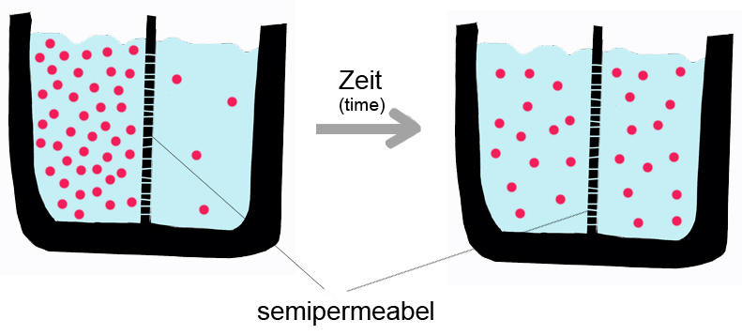
a. the semipermeable membrane has forced the particles to the right
b. the particles would have all moved but the time has run out for the experiment
c. particles tend to move from areas of high concentration to areas of low concentration
d. this diagram is in German and I don't understand it

- A microscope has an ocular lens with a magnification of x10. If a student uses an objective lens of magnification of x10, what is the total magnification?
a. x10
b. x20
c. x40
d. x100

11. This is the view under a microscope. Estimate the diameter of the field of view
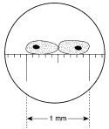
a. 0.5mm
b. 1mm
c. 1.2mm
d. 1.5mm

12. The part of the cell that selects which substances enter or leave the cell is the
a. cell membrane
b. mitochondria
c. vessicles
d. Golgi body
13. The cytoplasm is the material in which the contents of the cell are suspended. It is made of 75% to 90%
a. glucose
b. water
c. protein
d. fat

14. If a sultana is put into a glass of water, it swells up. This is an example of
a. diffusion
b. active transport
c. plasmolysis
d. osmosis

15. This diagram shows
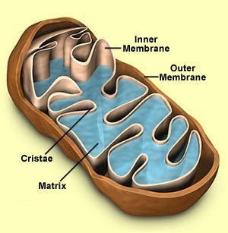
a. the nucleus
b. endoplasmic reticulum
c. flagella
d. a mitochondrion

Section B: Short Answer
Question 1 refers to the diagram below.

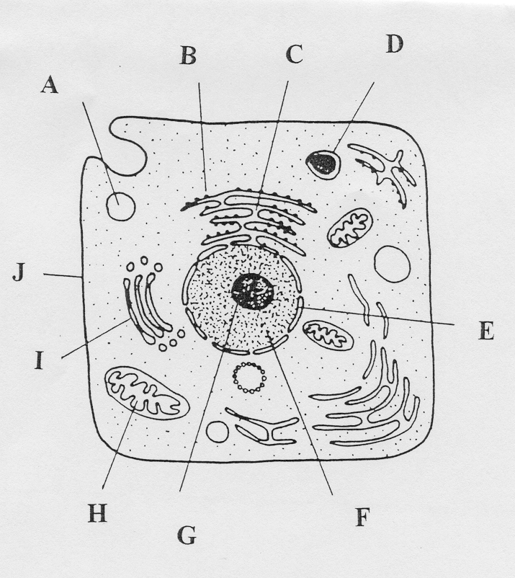

1a. Complete the labels from the diagram above.

B___________________________________________

C ___________________________________________

F____________________________________________

H___________________________________________

I____________________________________________

J____________________________________________

(6 marks)

- Explain the function of the following structures.

- B_____________________________________________________________
______________________________________________________________

- F___________________________________________________________________________________________________________________________

- H__________________________________________________________________________________________________________________________

- J___________________________________________________________________________________________________________________________
(4 marks)
Question 2.

List three types of active transport across a cell membrane.

_________________________________________________________________________________________________________________________________________________________________________________________________________
(3 marks)

Question 3.

Define the following characteristics of life:

Sensitivity___________________________________________________________Excretion___________________________________________________________

(2 marks)

Refer to the following diagram to answer Question 3

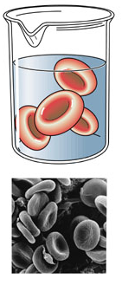
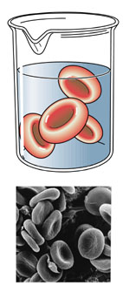
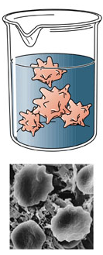
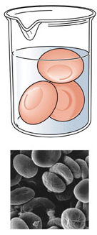
D: Normal blood plasma
A: 0.9% Saline
B: 2% Saline
C: 0% Saline

(6 marks)
3a Explain in terms of osmosis what has happened to the red blood cells in:

- Beaker C
_____________________________________________________________________________________________________________________________________________________________________________________________________________________________________________________________________________________________________________________________________________________________________________________________________________________________
- Beaker B
________________________________________________________________________________________________________________________________________________________________________________________________________________________________________________________________________________________________________________________________________________________________________________________________________________________________________________________________________________________

Question 4
The following table of data was collected using a large sample of students.

AGE | HEIGHT GAIN (cm/year)
 | FEMALES | MALES
6 | 6 | 6.1
8 | 5.5 | 5.7
10 | 5.2 | 5.3
12 | 8.3 | 5
14 | 2.6 | 9
16 | 0.7 | 2.7
18 | 0.2 | 0.6

a) Graph the data in the space provided. (5 marks)

Question 5
For each experiment below, identify the independent and dependent variables.
- A farmer applies different fertilizer to his cotton crops, to see which will make his plants grow the highest.
I: _____________________________ D: ___________________________
- In a study about headaches, doctors gave patients Alieve, Tylenol, Advil, and Excedrin, to see which medication would relieve the headache pain the fastest. The doctors timed how long it took the medication to work.
I: _____________________________ D: ____________________________
- A scientist wanted to determine the color flower that bees are most attracted to. She placed different colors of the same type of flower near each other and counted the number of bees that visited each flower color.
I: ____________________________ D: ____________________________
- A musician played various types of instruments at a medium volume to see how many dogs on the street started barking.
I: ____________________________ D: ____________________________

(4 marks)

